This protocol covers the steps to acquire a set of images. Detailed setup instructions of each software are in separate protocols. This protocol assumes that all setups, including the alignment of milling and imaging planes, have been finished.

1. Mount the sample
2. Power on and connect all hardware: camera (on top of the camera, switch pointing towards the back wall is on), DLP projector (gray box hanging inside at the fridge’s cable port), Arduino (two usb cables next to the computer on the cart)
3. Power on the mill (white switch on the black box next to the fridge) (have to power on the other things first otherwise the mill have significant problems)
4. If not yet done, upload required firmware (AOTFcontroller) to Arduino (sketch available from <https://micro-manager.org/wiki/Arduino>)

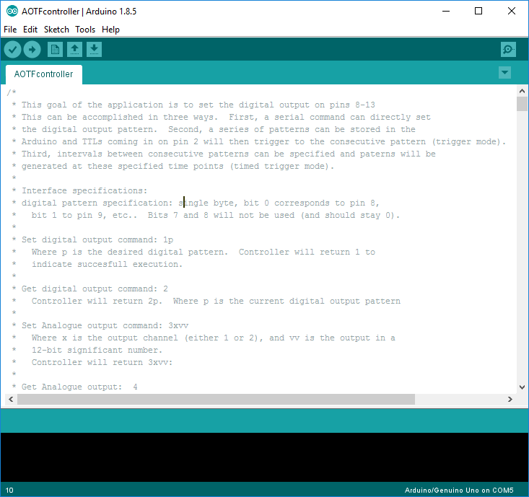

1. Open all required software: Mach3 (or other CNC software), DLP LightCrafter Control Software (press Connect when open), MicroManager
2. In LightCrafter software, change to desired test pattern for focusing the camera (eg. solid white)

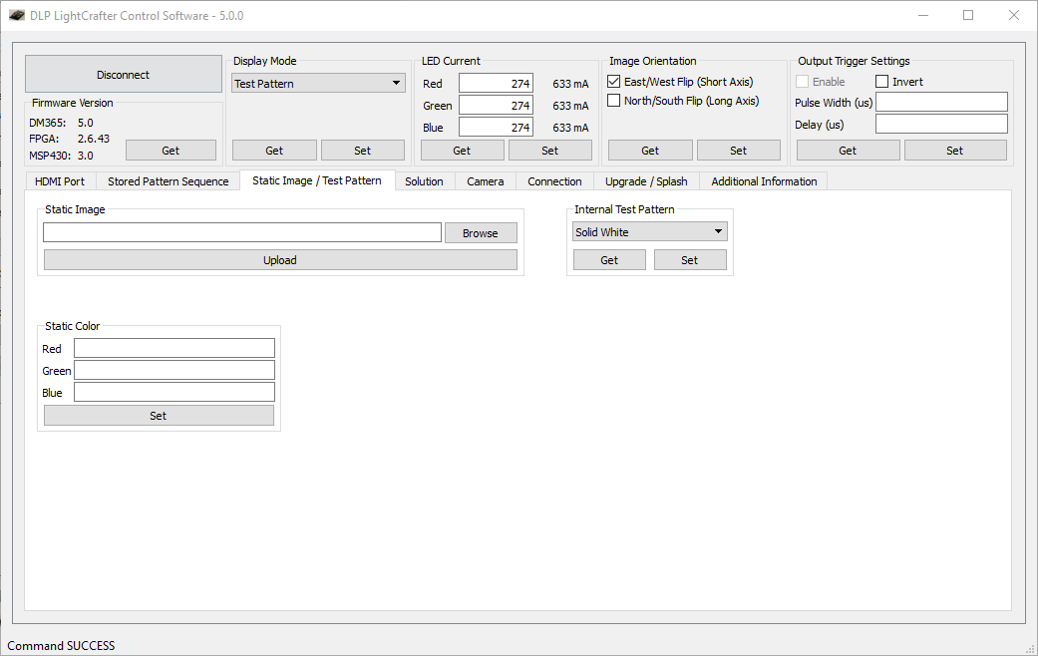

1. In MicroManager, open a live view window

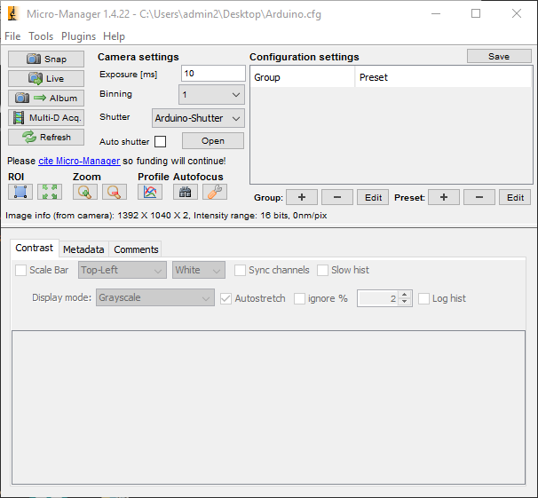

1. In CNC software, hit the reset button in the bottom left, jog the stage (to open jog hit tab, alternatively arrow keys are X,Y direction, pgup and pgdn are Z direction) in X and Y direction to find an edge of the sample. Confirm in the Live window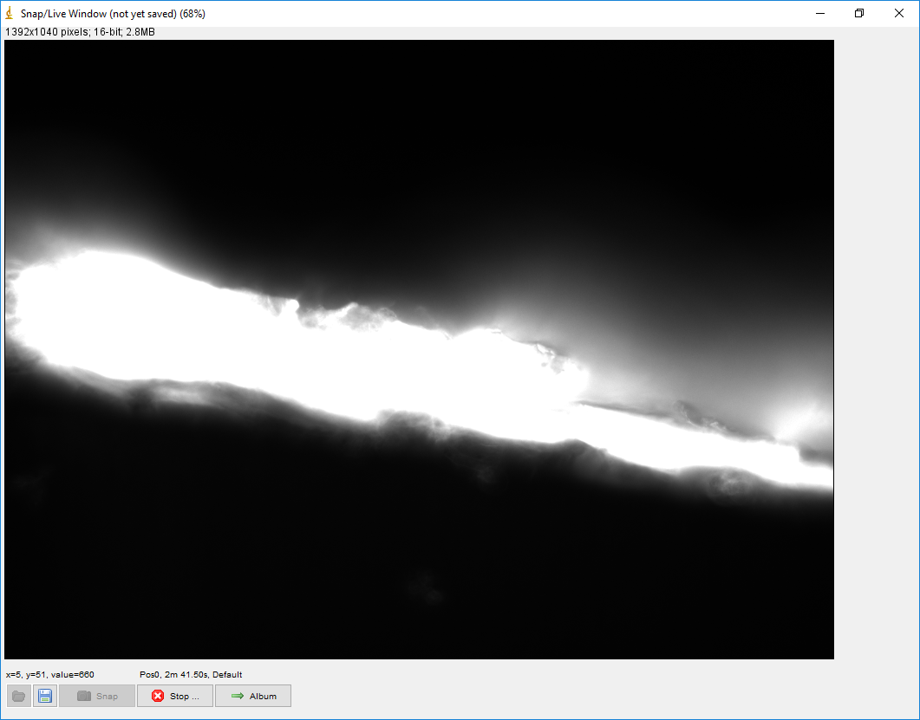
2. Change slow jog rate to a small number (eg. 5) to lower jogging speed, and carefully jog up and down to focus the camera (Probably using PgUp and PgDn buttons)
3. Slowly jog in X and Y directions to find desired imaging position
4. Zero/Home all three coordinates  
     
   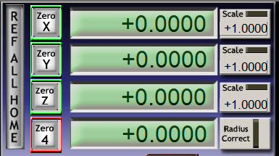

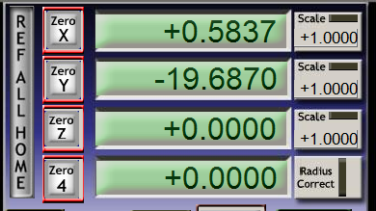

1. Load G Code for the milling cycles. Don’t click start

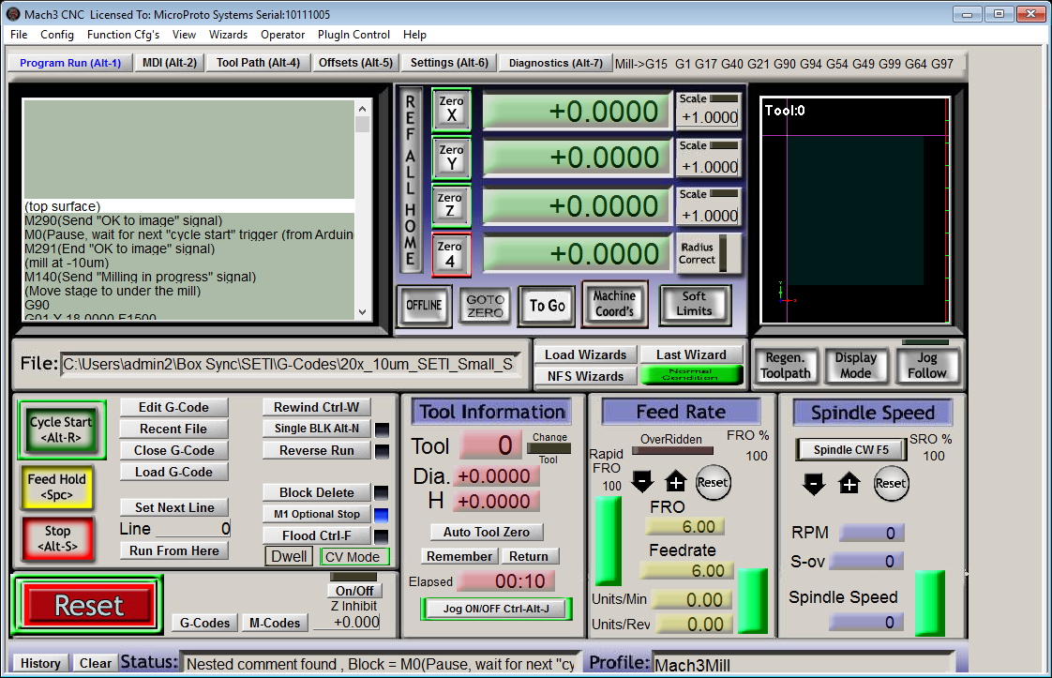

1. In LightCrafter software, set up sequence and load patterns. Pattern count is the number of pattern files used. For example, if you are using the 18ppx pattern, you would select 4 (3 pattern sub-images + 1 bright field image). Note that the order the patterns is based off of their file names. We recommend that you name the patterns files so that the files will always be loaded in a known order. An example is attached below. You can double check the order by clicking “Number” in the “2. Load Pattern Images” section. 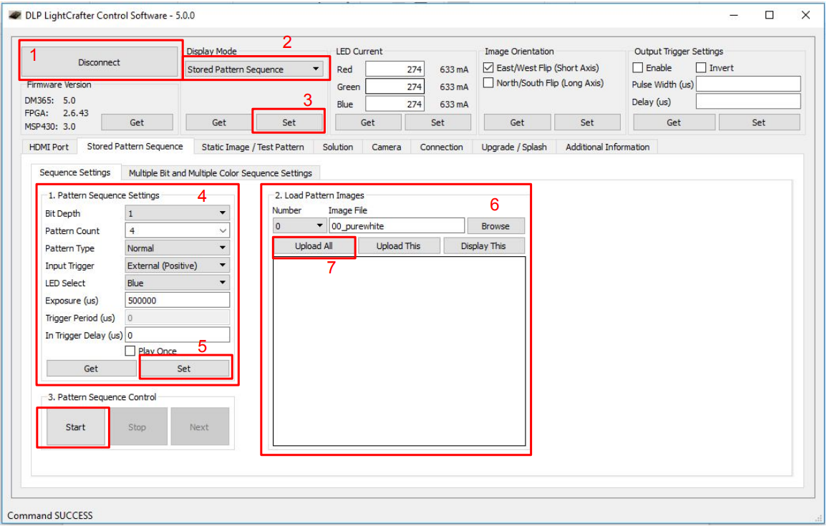  
   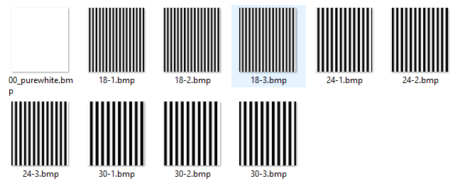

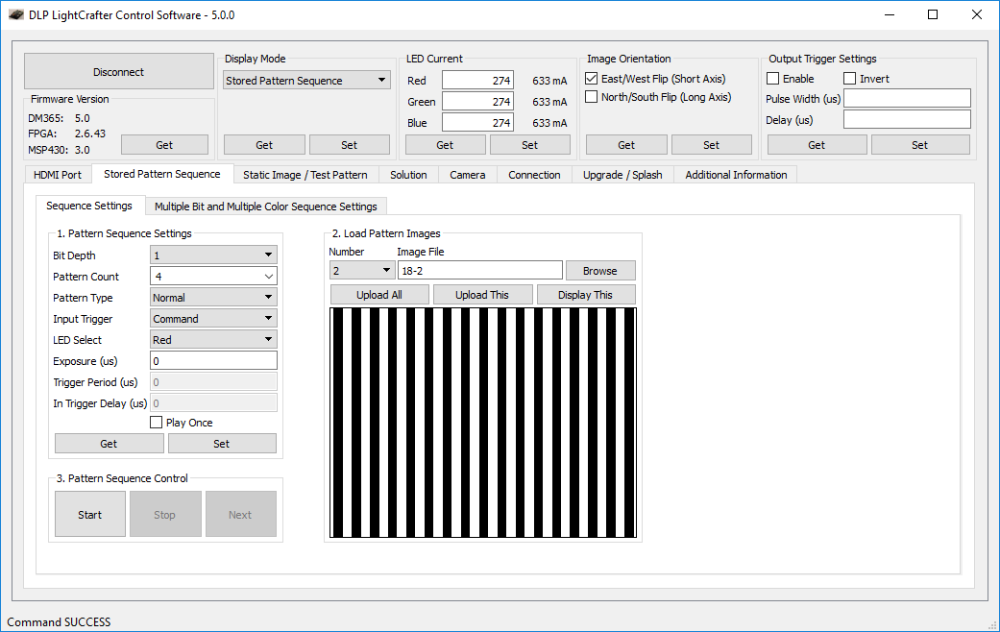

1. In MicroManager, open the controlling BeanShell script and change the acquisition parameters (eg. depth, number of patterns, file saving directory). Note that numPatterns in the Beanshell script refers to number of different patterns used, not number of pattern files, which is the case in the LightCrafter control software. For example, if you are using both 18ppx and 24ppx patterns, you would enter 2 in the Beanshell script and select 7 (2 x 3 pattern files + 1 bright field file) in the LightCrafter control software.

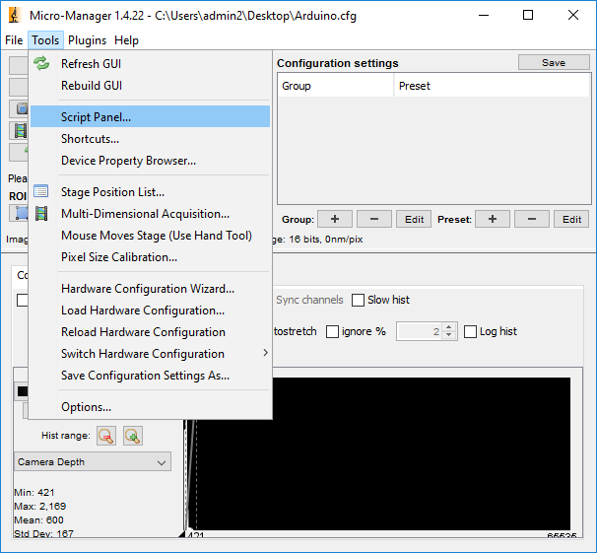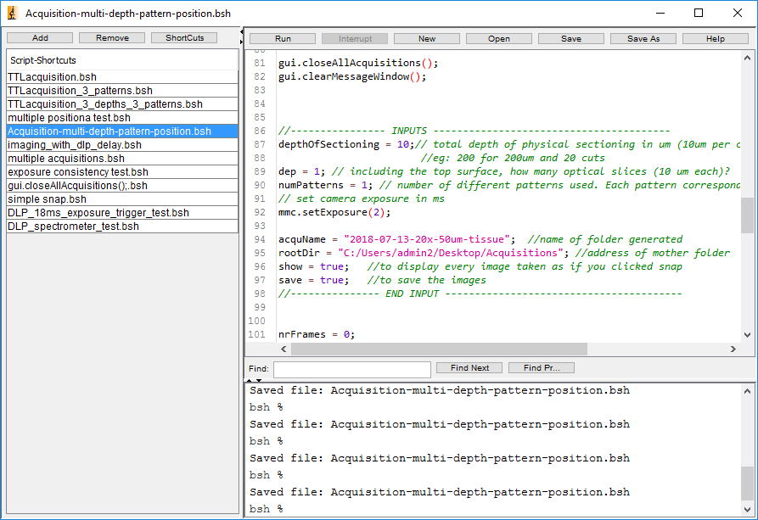

1. Click start in LightCrafter
2. Do a last check of everything
3. Click run in BeanShell
4. Watch for a few cycles to make sure everything is running smoothly
5. The folders containing the acquired images will be named “Pos#”. These need to be renamed. The number depends on the number of patterns used and the order of the pattern images in the LightCrafter software. In this example below, 3 different patterns were used (18ppx, 24ppx, and 30ppx). In the LightCrafter software, 10 total pattern `images were uploaded, and they were in the order of bright field → 18ppx → 24ppx → 30ppx. So the 4 resulting folders consequently contain images in this order.

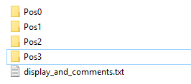

Bright field

18ppx 3si 0ap perfect bar

24ppx 3si 0ap perfect bar

30ppx 3si 0ap perfect bar